Title: The fitness value of ecological information in a variable world
Running title: The fitness value of information
Authors: Jacob Usinowicz^{1,2} and Mary I. O’Connor^{1,2}

Affiliations:
1. Department of Zoology, University of British Columbia, Vancouver, Canada
email: usinowic@zoology.ubc.ca
2. Biodiversity Research Centre, University of British Columbia, Vancouver, Canada
email: oconnor@zoology.ubca.ca

Keywords: ecology, information theory, population, fitness, community dynamics, coexistence.

Article Type: Synthesis

Author contributions: JU and MIC conceived of the study. JU conducted initial review and development of theory. JU created and analyzed models, and created figures with input from MIC. JU wrote the original draft of the manuscript, JU and MIC wrote and edited subsequent drafts.

Data accessibility statement: All supporting code and data will be publicly archived upon manuscript acceptance and a DOI included in the article. All code and data currently at https://github.com/jusinowicz/fvoi.git

This document file includes:
Abstract: 125 words
Main Text: 7436 words (with references)
Box 1: 602 words
Box 2: 460 words
References: 135
Figures: 5
Supporting Information document

Corresponding author:
Jacob Usinowicz
Department of Zoology
4200-6270 University Boulevard
Vancouver, BC V6T 1Z4
Abstract (max 120)
Information processing is increasingly recognized as a fundamental component of life in variable environments, including the evolved use of environmental cues, biomolecular networks, and social learning. Despite this, ecology lacks a quantitative framework for understanding how population, community, and ecosystem dynamics depend on information processing. Here, we review the rationale and evidence for ‘fitness value of information’ (FVOI), and synthesize theoretical work in ecology, information theory and probability behind this general mathematical framework. The FVOI quantifies how species’ per capita population growth rates can depend on the use of information in their environment. FVOI is a breakthrough approach to linking information processing and ecological and evolutionary outcomes in a changing environment, addressing longstanding questions about how information mediates effects of environmental change and species interactions.

Quantifying information in ecology
Biology is built upon information.From genetic architecture (Smith 1999; Goldenfeld & Woese 2007; Tkačik & Bialek 2016), to sub-cellular biomolecular networks (Tyson et al. 2002 ; Woods & Wilson 2013; Cai et al. 2018), to the countless examples of derived sensory apparatus in organisms life is replete with mechanisms for detecting, processing, and storing information (Dangles et al. 2009). Natural selection itself is an information process, where changing gene frequencies encode population-level information about the fitness consequences of the environment (Smith 1999; Frank 2012). Ecological studies account for the myriad ways in which organisms acsoss all kingdoms of life respond to changing environments and use cues in their environment to find resources, refuges, and reproduce (Crespi 2001; Crone et al. 2009; Gil et al. 2018), but accounting for the explicit role that information plays in population, community, and ecosystem dynamics remains a largely unexplored research frontier (O’Connor et al. 2019; Marleau et al. 2020).
Ecologists have long been interested in the ways that organisms detect and respond to cues in their environment, but recently information is increasingly acknowledged as a universal and essential component to life in fluctuating environments (Berhardt et al. 2020). Historically, information has been equated with a variety of cues including climatic shifts associated with seasonal change that drive phenology in growth, germination, reproduction, hibernation, and dormancy (Cohen 1966; Ellner 1997; Clauss & Venable 2000; Thackeray et al. 2016; Ten Brink et al. 2020). Information has also been studied in the form of social or chemical signals used to find food (Danchin et al. 2004; Magrath et al. 2015; Gil et al. 2018), shared between bacteria to monitor local densities (Crespi 2001), or transmitted between plants as volatile organic compounds triggered by defense against herbivor (De Moraes et al. 1998; Baldwin et al. 2006). While these important studies have guided scientific progress, taken collectively they create an idiosyncratic, system-specific perspective on information the precludes generalization across systems. Furthermore, they tend to lack a dynamical understanding of information’s role in populations, communities, and ecosystems.
A generalizable definition of information that formalizes the intuition behind many biological cues can be found in information theory (Goldenfeld & Woese 2007; Tkačik & Bialek 2016). In information theory, information measures the uncertainty or “surprisal” of an event: less-probable (more surprising) events are more informative in the sense that an observer is better-informed after learning that a rare event has occurred. Formally, surprisal is quantified as the log (1 / probability (event)) (related to the log-odds of an event) and this standardized unit forms the basis of the majority of information theory concepts including the Shannon Entropy (familiar to ecologists as the Shannon evenness). To illustrate this definition of information, consider the example of generally hot, arid environment where rain occurs only within a short rainy season. The chance of experiencing rain on any particular day is low, so it is unsurprising to learn that it will not rain today; low surprise indicates that little information has been gained by an observer about the weather. Learning that it will rain carries more surprise, and thus conveys more information. It is also possible that one variable, such as temperature, contains information about another variable, such as rain. If temperature is generally constant regardless of precipitation, then knowing the temperature today is uninformative about the chance of rain (and vice versa). However, if rain is triggered by the arrival of a cold front then the consequent temperature drop on that day carries a great deal of information about the chance of rain. Information theory formalizes this shared information through a variety of metrics all based on units of surprisal, the most common of which is the mutual information (MI).
Information theory shows us that information itself is measureable but is inherently free of value or meaning (Frank 2012). Ecology, on the other hand, has been more interested in the biological value of information without necessarily understanding its underlying role. What is necessary then are frameworks that link the two and make it more transparent how much ecological dynamics are driven by information versus the biological utility that organisms derive from it (Frank 2012). The mathematical framework for the fitness value of information (FVOI) (Donaldson-Matasci et al. 2010; Rivoire & Leibler 2011) is a key innovation developed to bridge information theory with biological concepts of species’ fitness. The core insight of this theory is that the biological value of information can bemeasured via its affects on a population’s fitness. Ecology and evolution share a universal measure of population-level fitness measured in terms of per capita population growth rates. The FVOI quantifies how information increases (or occasionally decreases) a population’s fitness in varying environments by measuring changes in per capita population growth rates; if information improves an organism’s ability to consume resources, locate mates, or survive then per capita growth rates increase relative to when information is absent (Gould 1974; Stephens 1989; Donaldson-Matasci et al. 2010; Rivoire & Leibler 2011)(Figure 1). Because the formalism is built around per capita growth rates, the FVOI overlaps with models and other frameworks for analyzing stochastic population growth, including classic models of bet-hedging in annual plants (Gillespie 1974; Philippi & Seger 1989) and copepods (Hairston & Dillon 1990), and coexistence theory (Turelli 1978; Chesson & Warner 1981). However, by explicitly parsing the information content of per capita growth rates from other fitness components, the FVOI offers deeper insight into the dynamics of populations in fluctuating environments (Stephens 1989; Donaldson-Matasci et al. 2010; Rivoire & Leibler 2011).

A major advantage of the FVOI framework is that it simplifies the accounting of costs and benefits of information use because it shifts focus from the organismal to the population level. The extent to which information can increase fitness must account for concurrent costs and benefits associated with information detection and processing -- organisms bear metabolic costs to implementing and maintaining sensory machinery (Koch 2004; Keller & Surette 2006; Nelson & MacIver 2006; Barth & Schmid 2013; Gil et al. 2018) and cellular or biochemical networks for information (Laughlin et al. 1998; Bruce et al. 2007; Bullmore & Sporns 2012; Crisp et al. 2016); although, in some cases organisms may take advantage of biochemical pathways that are already in place (Baldwin et al. 2006). On the other hand, information can have emergent benefits, as when matching the phenology of life history events such as flowering and reproduction with resources for growth compounds benefits through pollination success (Strauss 1997), herbivory avoidance (Schauber et al. 2002), or a reduction in interspecific competition (Usinowicz et al. 2012). The FVOI inherently encompasses both costs and benefits to using information because quantifyingthe overall net impact of these processes is subsumed in rates of population change.

The goal of this paper is to develop the FVOI as a general framework that guides ecological intuition about information’s role in ecological dynamics; it is not our objective to review information theory as others have (Goldenfeld & Woese 2007; Tkačik & Bialek 2016) and we only define specific concepts as they become relevant to in-depth understanding of FVOI. In the first section Measuring the fitness value of information we present an intuitive heuristic derivation of FVOI for general ecological audiences and review the mathematical framework first presented by Donaldson-Matasci et al. (2010) both in the text and in more detail in Box 1. and describe how FVOI can be measured both in theory and in empirical settings.In the next section Parsing information’s contributions to fitness we briefly review the historical development of information-based population models in ecology in order to illustrate core principles of FVOI, point out where the theory can inform empirical applications, and demonstrate a novel extension to competitive communities. Finally, in Biological examples of information’s value we reviewstudies where organisms make fitness-related decisions (behavioral and developmental) in response to environmental cues (biotic and abiotic); beyond simply reviewing the literature, our goal in this section is to highlight the potential for FVOI to facilitate novel, testable ecological hypotheses in particular systems (Marleau et al. 2020), and help unify our understanding of anthropogenic impacts on the information content of environmental cues (McMahon et al. 2017; Barton et al. 2018). A major strength of the FVOI is that it can link these disparate bodies of work through fundamental principles; in a variable and uncertain world organisms constantly face decisions (or, developmental junctures) which can ultimately have population-level impacts on the long-term persistence of their species, and that average fitness outcomes improve when populations of organisms make informed decisions.

Measuring the fitness value of information
Evidence that information has fitness value seems unequivocal when considering the countless adaptations found in species to detect, process, and produce cues and signals. An integrated measure of the fitness value of information can be made by measuring population growth rates with the benefits, costs, and community context embedded in population dynamics (Cover & Thomas 2006; Donaldson-Matasci et al. 2010; Rivoire & Leibler 2011). Here we present a heuristic derivation of the FVOI for ecology that synthesizes studies which have derived this relationship from fundamental mathematical, information-theoretic principles to understand evolutionary dynamics (Box 1) (Donaldson-Matasci et al. 2010; Rivoire & Leibler 2011).
Fitness can be given a concrete, mathematical, definition. Ecologists (Turelli 1978; Chesson 1994; Ellner et al. 2016) and evolutionary biologists (Haldane & Jayakar 1963; Cohen 1966; Ellner 1987) measure fitness using per capita population growth rates: fitness is the expected value (average) of the logarithm of per capita population growth rates (Frank 2016). Ecologists commonly model population growth with discrete-time models of the form

. (1)

Here, λ_{i}(t) is the per capita growth rate of population i, which is itself usually a function of demographic parameters including survival and fecundity (e.g., Box 2). This indexing may refer to a species, a phenotype, or a strategy depending on the study and its context, but what is consistent is that a;; individuals within population i have an identical response. A population’s expected long-term growth rate 𝜌_{i} is the geometric mean of the per capita growth rate:

(2)

The E[ ] signifies the expectation over many realizations of the term in brackets and is defined for both discrete- and continuous-time models. The continuous-time analogue is and G_{i}(t) = 𝜌_{i} is the log-growth rate.
In theory, 𝜌_{i} can be calculated for any specification of λ_{i}(t), meaning it is applicable to any population. By measuring 𝜌 under different models or parameterizations of λ_{i}(t), biologists have used it to compare how different processes or environmental conditions impact the fitness of populations. For example, the theory of coexistence in fluctuating environments (Turelli 1978; Chesson 1994) is effectively based on an underlying comparison of two versions of 𝜌_{i},one with and one without a varying environment; their difference measures how much population per capita growth rates depend on environmental variation (Usinowicz 2015; Shoemaker & Melbourne 2016; Barabás et al. 2018). In evolutionary theory, 𝜌_{i} provides a measure of the fittest strategy or adaptation when compared across different phenotypes in a population (Cohen 1966; Ellner 1997).
The FVOI framework is based on comparing 𝜌_{i} under different assumptions of information availability, usage, and cost. This assumes of course that λ_{i}(t) can be calculated with and without information components. Stated pseudo-mathematically (see Box 1 for full mathematical derivation), the fitness value of information is measured as the difference between 𝜌(informed) and 𝜌(uninformed):

(3)

Application of Δ𝜌_{i} to some simple models of population growth has shown that at least two key information-based mechanisms (sensu ‘coexistence mechanism’) contribute to fitness (Donaldson-Matasci et al. 2010; Rivoire & Leibler 2011). The first mechanism defines the maximum fitness benefit that could be obtained by perfectly detecting and utilizing a cue. It is equivalent to the information-theoretic correlation between environmental variation and the potential cue (a particular pattern that precedes variation), known as the mutual information (MI) (Figure 1). The MI measures how much information about the availability of a good (or bad) environmental condition is potentially available to a population, and is thus proportionate to the maximum potential fitness value of information (in a cue) (Donaldson-Matasci et al. 2010; Rivoire & Leibler 2011). The MI is generally positive and can be zero when the cue and the environment are independent.
The other important component in the FVOI identified thus far in theory estimates the fitness consequences when a population’s response to patterns of environmental variation fails to utilize all of the available information (the MI). Quantitatively, this difference is equivalent to the Kullback-Leibler (KL) divergence (D_{KL}), which is a statistical distance (but not a true metric) between two probability distributions; biologically, it measures how much the population’s distribution of responses to the environment (across individual organisms’ internal models of the environment) differs from the real probability distribution that describes environmental fluctuations (Box 1, Figure 1C,D)). If detection of and response to the environment perfectly anticipate patterns of environmental variation then the KL divergence is zero and the population can fully utilize the information present (in the cue) (i.e., the MI).
One important result from the FVOI is that the MI between a cue and future environmental conditions defines an upper limit for how much a source of information can improve fitness (Donaldson-Matasci et al. 2010; Rivoire & Leibler 2011). This result is useful because it confirms intuition that uninformative cues should not be expected to contribute to fitness and provides justification for using MI as a simple metric to identify cues with potential fitness value.

Parsing information’s contributions to fitness
In practice, Δ𝜌_{i} can be applied to quantify the fitness value of information whenever per capita population growth rates can be quantified in fluctuating environments. Measurements of 𝜌_{i}(informed) are commonly made in studies of population persistence and coexistence in fluctuating environments, whether it is through direct experimental meaurements (cite, e.g. Tess), paramterization of mathematical models with observational data (e.g. Adler, me), or a combination of the two. Measuring 𝜌_{i}(uninformed) may require novel approaches, for example experiments that break the correlations between cues and population fitness, and to our knowledge have never been performed. However, the utility of the underlying mathematical framework for the FVOI and its different expressions (Box 1; Donaldson-Matasci et al. 2010; Rivoire & Leibler 2011) is that it provides other options to accomodate a variety of ecologcal data. In particular, whenever 𝜌_{i}(informed) is measured in conjunction with the environment and potentially informative cues (which may themselves be embedded in the environmntal data), then it should be possible to quantify Δ𝜌_{i} by instead calculating the MI and KL divergences. In this section, we illustrate how these lines of evidence are used to estimate FVOI by reviewing the theoretical literature that has explored FVOI in single-species population models. We review a classic motivating system in ecology (dormancy and germination in annual plants) where the idea of informed resource allocation links ecology to probability theory’s concept of betting. We also review how the simplest mathematical models of dynamics that link ecology and classic betting problems have provided tremendous insight into natural dynamics, but much still stands to be gained by extending analysis to more complex models which include dormancy, density dependence, and interspecific competition. Details of all simulations presented in this section can be found in the Supporting Information, and code and data files found at https://github.com/jusinowicz/fvoi.git .

Betting on success: timing of seed germination in annual plants
A classic motivating example for understanding the FVOI is the timing of germination of annual plants in fluctuating environments. Environmental conditions that directly affect germination and reproductive success differ each generation, bounded within a distribution of possible sets of conditions. Each generation, dormant seeds within the population can germinate or remain dormant, and if they germinate the resulting adult plant will produce new seeds, the number of which will reflect the suitability of the environment. Ecologists have drawn on classic mathematical models of betting from probability theory to model the dynamics of populations in this system (Cohen 1966; Ellner 1997), and extended them to more complex community interactions between zooplankton (Cáceres 1997), fish (Chesson & Warner 1981; Secor 2007), trees (Usinowicz et al. 2017), and viruses (Stumpf et al. 2002). A population is treated as a bettor who has some amount of capital (seeds) to gamble on event outcomes (environment conditions); the role of the bettor is to decide when and how much to gamble on each event (the conditions each year). The betting analogy also shows the value of information more intuitively; in general, knowledge of likely outcomes allows a bettor to increase earnings by allowing them to make informed bets. However, these previous applications have only quantified population-level consequence of observed demographic patterns without seeking a deeper understanding of the role of information in driving per capita growth rates.
Drawing the connection between betting in probability theory and population dynamics of organisms in fluctuating environments requires some assumptions. In this example, the ecological equivalent of an ‘event’ is a multivariate space of environmental conditions, denoted E (Box 1), that are relevant to the organism’s biology, e.g., moisture, temperature, and nutrient availability. An ‘event outcome,’ denoted e (Box 1), is any particular combination of these conditions (visualized as a point that falls somewhere in the multivariate space). It is common (but not necessary) to model discrete events because gambling has discrete outcomes; a particular number is drawn, or a particular horse wins a race. When analyzing ecological data, it may be possible to fit continuous distributions to a discrete sampling space, but in many cases it may be preferable to work with the observed distribution of samples to construct the (non-parametric) distribution of environmental states.
Betting examples that motivate theory often refer to a bettor with decision-making ability. This bettor has an internal model of probabilities that it uses to make betting decisions (denoted by x_{i,}(e) in Box 1). In reality, a bettor’s internal model is just a device to illustrate a mathematical concept and should not be taken too literally; in the mathematical representation of dynamics, the internal model is encapsulated by a function of a random variable x_{i,}(e), whose underlying probability distribution dictates the proportion of its resources to bet on each event (e.g. Box 1). Extending the analogy of internal models to ecological dynamics does lead to interesting biological questions. Organisms, or even populations, may have the ability to learn and improve decisions by learning the odds in a way that is more similar to a bettor that learns probabilities. In other cases, “decisions” are actually hard-wired life history transitions that are initiated by a particular stimulus or cue. For example, the “decision” of a seed to germinate is not behavioral, but is driven by a biochemical reaction initiated at the seed’s surface that generates a cascade of internal changes. The “internal model” is actually the population-level manifestation of these decisions because the allocation of resources to reproduction in each generation is a population-level phenomenon. Thus in making analogies to probability theory, we are actually treating the population as a bettor whose internal model is really a distribution of individual-level decisions made across all individuals. In our notation, 𝜌_{i} is the rate at which a bettor accumulates wealth or a population accumulates new individuals (i.e. per capita growth).
A naive bettor (or population) is uninformed about the distribution of possible outcomes or states. The internal model of this population (bettor) may take various forms, depending on the context, but one common representation is a uniform distribution over states (outcomes) because without further knowledge the best that a bettor can do is assume that each state is considered to be equally likely. This important baseline appears in numerous information contexts, from Bayesian statistics (uninformed priors) to maximum entropy (maxent) in information theory studies; a uniform distribution of probabilities produces the maximum value of the Shannon entropy (Cover & Thomas 2006). In the FVOI, the maximum entropy case can similarly be used to establish a baseline of per capita growth rates because it is the best that a population can do when it is entirely uninformed about future environmental states. However, this does not mean that other distributions might be more biologically appropriate in other contexts and the framework works regardless of this choice. Furthermore, we do not expect uniformity to occur in real populations and emphasize that this is a mathematical device which simplifies and standardizes analyses. Formally, we denote the uninformed per capita growth rate as 𝜌_{i}(uninformed) = 𝜌_{i} ( x_{i} (E ~ U(0,1) ) ) = 𝜌_{i} (E~U) in this specific case, where x_{i} (E) is the rate at which a population gambles on each environmental state according to its internal model, U(0,1) denotes the uniform distribution over the interval 0 to 1, and 𝜌_{i} (E~U) is a shorthand that we use for the uninformed population (see Box 1 for notation).
In many cases, a population (bettor) may actually have some information about the distribution of odds of possible states (outcomes), which we denote formally as 𝜌_{i} ( x_{i} (E) ) = 𝜌_{i} (E) simply to indicate that some distribution of probabilities is being used as an internal model for allocation of resources (bets). A bettor might learn something about the distribution of expected outcomes, for example by knowing how often each horse in a race has won in past races. In a population, the information may also exist as learned associations (Aplin et al. 2015; Gil et al. 2018), but it can also appear as a phenotypic distribution that has evolved in response to historical temporal patterns in environmental conditions (Kussell & Leibler 2005; Donaldson-Matasci et al. 2008; Frank 2012). In either case, the optimal allocation strategy for reproductive effort under minimal information (i.e., knowing only the odds of events based on the assumption that past distribution of occurrences predicts future odds) is the same, and the solution is for a population to divide reproduction among expected events (environmental states) in proportion to their odds of occurring. This is referred to as the Kelly criterion or Kelly betting (Cover & Thomas 2006), and was derived to explain the best strategy for an individual bettor that must allocate bets optimally to maximize winnings across many horse races (Kelly 1956; Cover & Thomas 2006). The Kelly betting strategy is fairly robust because it is independent of the underlying mechanism (cognitive or evolutionary) (Box 1); thus even without predictive information about future states provided by a cue (i.e., the conditional probability of environment, given a cue (3)) an optimal long-term strategy exists for timing reproduction. The Kelly criterion is also the choice of uninformed baseline used orginally by Donaldson-Matsci (2010) in their original development of the framework.
If organisms in a population are able to detect information which can be used to predict future events, then allocation (betting) strategies exist that are even more efficient than classic Kelly betting. For example, if our imaginary plant populations are attempting to germinate in an arid environment like the one discussed briefly in the introduction, and reproductive success is maximized when germination is timed coincident with optimal amounts of water each season, we can explore strategies when populations are able to respond to environmental cues that signify future water availability. In Box 1, the distribution of all cue states is C, and each realization as c.If the amount of moisture today is a cue that is predictive of the amount of rain in the future, then there is high MI between the cues C of moisture and the states E of rain which can be exploited. The MI is itself driven by the conditional probability of seeing a certain amount of rain in the future given current moisture levels (written formally as p_{i} (E|C) ), which may be a more familiar notation. As a probability, p_{i} (E|C) ranges between 0 and 1, 0 indicates total independence of these two events, and 1 indicates that the current cue is perfectly predictive. The corresponding per-capita growth rate is 𝜌_{i} ( x_{i} (E|C) ) = 𝜌_{i} (E|C).
The additional fitness gain that is possible when information is available (e.g., MI > 0) can be substantial (Box 1; Donaldson-Matasci et al. 2010). The optimal strategy with informative cues is a conditional version of the Kelly criterion (Cover & Thomas 2006), where bets (allocations) are made in proportion to the conditional probabilities (3). As long as the information is reliable (i.e., the conditional probability distribution has less variation around the true state than the uninformed marginal distribution) then the payout will always be better and Δ𝜌 _{i} will increase (Box 1; Figure 2A. The FVOI (Δ𝜌_{i} ) is the difference between these two growth trajectories, estimated as the comparison of the rates of population increase over time (Figure 2C). Note from Figure 2C that the FVOI and MI are equivalent in that scenario, showing that populations have fully utilized the information in the cue and maximized the FVOI.
In the real world, populations rarely invest all of their resources into per capita growth and instead retain resources across reproductive events. This strategy, known as bet-hedging (Gillespie 1974; Philippi & Seger 1989), is ubiquitous (Clauss & Venable 2000; Stephens et al. 2002; Childs et al. 2010; Tielbörger et al. 2012; Furness et al. 2015). It is evident wherever there is some form of “storage”, whether it is in long-lived adults such as in perennial plants (Adler et al. 2006; Usinowicz et al. 2012) or adult fish (Secor 2007), or in propagules such as a seed (Sears & Chesson 2007; Jose M. Facelli et al. 2008) or eggs (Cáceres 1997) that can remain dormant for long periods. Bet-hedging is optimal when odds are “subfair,” the mathematical term for a set of outcomes where the sum over the reciprocals of the odds of each outcome is greater than 1 ( sum(1/odds) >1 )(see Cover & Thomas 2006 or Ellner 1997 for details). Basic organismal physiology tends to constrain organisms such that there will be some conditions under which reproduction rates approaches 0: the odds of reproduction success when environmental states that drastically reduce or even preclude reproduction likewise approach 0. Brief consideration of the equation for subfair odds above leads to the observation that we should probably never expect nature to be fair; even one outcome with odds approaching zero will lead to very large or even infinite sums. Because nature is not fair, bet-hedging should be the norm.
Information improves fitness for bet-hedging populations in variable environments (Box 1: Donaldson-Matasci et al. 2010). As with model 1 (Fig 2A), the per capita growth rate for a bet-hedging population is higher when individuals use a cue to time reproduction to align with favorable conditions (Fig 2B). Per capita growth rate in the bet-hedging population is lower, however, because dormancy introduces constraints on the FVOI. Dormancy represents increased phenotype specialization when individuals of a certain phenotype are increasingly specialized to emerge in response to specific cues. This physiological trade-off between generality and specialization can prevent a population from fully exploiting the information in a cue (see Box 2). The fitness cost of a physiological constraint like dormancy can be measured by parsing the FVOI, which we have done numerically in Fig 2C-D. In the first scenario, the FVOI is equivalent to the MI (figure 2C) revealing that the population/organism are able to perfectly use the MI in the environment. In the second case, the FVOI measured by the difference in slopes is no longer equivalent to the MI (Figure 2D). Note that this difference between Δ𝜌 _{i} and MI is the KL divergence, which measures the information a population fails to use.
The applicability of these theoretical insights to real populations remains an open question. On the one hand, they suggest that, at least in the context of competitive dynamics,almost any information use has the potential to increases a population’s fitness, and certainly the use of cues to anticipate environmental conditions is ubiquitous in real organisms. Likewise, the mathematical conditions that make information advantageous (i.e., variable environments with sub-fair odds) are probably the rule in nature. A primary point of contention in the annual plant systems, where bet-hedging has been the most well-studied, has been whether the conditions that make a cue informative actually exist (Venable & Lawlor 1980; Clauss & Venable 2000). To our knowledge, no attempts have been made to measure the MI between the environmental conditions which benefit annual plant reproduction and cues that seeds use to anticipate them. It also remains unknown how often and to what extent biological constraints (including dormancy) might reduce the FVOI to a point where there is no net fitness value. Finally, many of the insights garnered here are based on theory that has dealt with single-species populations without even conspecific interactions (such as intraspecific competition). The handful of studies that consider the fitness value of social information point to a complex landscape of fitness tradeoffs that can be dependent on several factors, but tend to reflect a general potential for information to improves fitness(Gil et al. 2017, Gil et al. 2019, Hein and Martin 2020). .

Information’s contributions to fitness in communities and community dynamics
Given the importance of information to population dynamics and trajectories in scenarios that consider only the population and its environment, we expect that information use and the fitness advantages it confers may be an important dimension in fitness in communities. In the single-species models studied to date only a direct influence of information on fitness has been analyzed (Donaldson-Matasci et al. 2010; Rivoire & Leibler 2011), and these models do not account for the density- and frequency-dependent feedbacks that drive biodiversity (Adler et al. 2007; Hart et al. 2017; Usinowicz et al. 2017; Letten et al. 2018). Probability theory has also not probed models with feedback dynamics that would be informative in the context of communities and multiple interacting populations. A handful of models explore the fitness value of information in the context of social information, but their relationip to the body of theory behind the FVOI remains unresolved (Gil et al. 2017, Gil et al. 2019, Hein and Martin 2020).
How do species interactions mediate the fitness value of information?
Here we present extension of a classic ecological model of population dynamics in fluctuating environments to which the potential for information-driven dynamics have been added(Box 2). The first of theseis a novel extension of the lottery model (Chesson & Warner 1981) where species compete based on the proportion of offspring that emerge each generation (e.g., germinating proportions of seeds) which varies randomly. We introduce the potential for information to be used in the emergence process according to an early season cue that predicts whether environmental conditions are favorable in a given year (high MI between early and later season conditions). This is implemented by making the proportion of emerging individuals a function of the conditional probability of seeing a favorable environment given a cue ( p(E|C) ). In this form, the lottery model with information is an extension of the simple single-species models used in Donaldson-Matsci et al (2010), and an information-driven, extension of the lineage of bet-hedging models (Ellner 1997; Hairston et al. 1995) with competition added. An overview of this model for two species is given in Box 2, and the different competitive dynamics when germination is conditioned on a cue or not, are given in Figure 3.
Information use benefits species that are competing for a shared, fluctuating resource, as evidenced by comparing population growth rates with and without the use of an environmental cue in Figure 3. For a single resource environment, at a particular level of overlapping interspecific resource use (i.e., niche overlap), the ability to use information about temporal patterns in the environment has clear and quantifiable fitness benefits. It follows to ask, does the FVOI depend on the niche overlap of competitors? In order to answer this question, we simulated the model across different levels of resource use overlap (keeping species’ average reproduction rates equivalent to one another) and applied Δ𝜌_{i} to measure changes in the FVOI across scenarios. It is clear from the results in Figure 4A that increasing niche overlap through increases in species’ shared environmental preferences leads to a decrease in FVOI. This means that high interspecific similarity in resource and environmental needs also decreases the opportunity for species to avoid competition through information about patterns of variation in those resources.
We can also ask, how does information influence coexistence? We can address this question by applying Δ𝜌_{i} to the model simulated over the same range of resource overlap scenarios and calculating the niche differences (note that species were given equivalent fitness) from the two different sets of low-density growth rates, 𝜌_{i} (E|C) and 𝜌_{i} (U) following previous methods (Carroll et al. 2011; Grainger et al. 2019). The magnitude of niche partitioning with 𝜌_{i} (U) at any particular level of resource overlap reveals the potential for resource partitioning alone to promote coexistence, while the difference in niche partitioning between 𝜌_{i} (E|C) and 𝜌_{i} (U) reveals the extent of niche differentiation that is purely information based. Information can promote coexistence by further decreasing niche overlap and that this is an effect that can be distinguished from purely resource driven niche partitioning (Figure 4B). Since broader niche differences facilitate coexistence and the maintenance of biodiversity, our results also show that information can therefore play a role in the maintenance of biodiversity in natural communities.

Fitness value of Social Information
Information exists in the environment in the patterns and behaviors of other organisms, in addition to patterns in the environment as we have considered so far (Gil et al 2018). When organisms detect physiological, chemical, or behavioral responses in other individuals these cues are called social information. We also investigated the FVOI in a model of social information based on classic Lotka-Volterra dynamics (Box 2) (Gil et al. 2018). This version of the model includes an additional density-dependent term with interaction rates that determine the value of social information passed between con- and heterospecifics. We illustrate the different competitive dynamics with and without social information in Figure 4. The simplicity of this model makes it straightforward to assess analytically, and serves as a simple proof-of-concept because applying Δ𝜌_{i} to the model in Box 2 recovers the term B_{i}(N_{i}...N_{n}) (Box 2) included by Gil et. al to represent information dynamics. This means that the FVOI is equivalent to the value of social information in this example, and shows more broadly how different types of ecological information can be nested and compared within the more general FVOI framework.

Biological examples of information’s value
All populations must contend with fluctuating environments, and most temporal patterns of variation contain information that can be used to inform predictions about likely future conditions (Pennekamp et al. 2019). By using information in the environment, organisms stand a better chance of tracking beneficial conditions and avoiding detrimental ones. Information is present in cues when they correspond to patterns of environmental variation, and information is useful when it is predictive of conditions that promote or inhibit species’ growth or reproduction, and when that information is detectable to the organisms. Species have evolved or learned responses to specific cues, which signal behavioral decisions or life history responses. Although the majority of our review has considered environmental cues to this point, cues may also come in the form of social information from con- or heterospecifics that help avoid predation, or improve the likelihood of finding resources or mates. A vast number of studies enumerate examples of this ecological information without explicitly connecting cue responses to population or community dynamics. Here, we discuss how ecological information, in the form of abiotic and biotic cues, mediates fitness via two primary pathways: 1) environmental information, when demographic rates change in response to a unidirectional flow of information from environment to organism and 2) social information, when population densities change in response to exchanges of information between con- or heterospecific individuals.
Demographic information includes cues that trigger shifts in demographic rates, often through life-history changes. Demographic responses are independent of population densities. In a mathematical model, demographic responses would be represented by a changing parameter value such as fecundity, germination or survival rate (Box 2). Some of the most well-studied examples of demographic information include cues for the timing of dormancy and emergence in plants (Thackeray et al. 2016; Montgomery et al. 2020), animals (Koštál et al. 2017; Wilsterman et al. 2021), and bacteria (Jones & Lennon 2010). Plants that experience seasonally harsh conditions often have dormancy strategies where regrowth and germination (Tielbörger et al. 2012; Commander et al. 2017) respond to cues associated with the onset of more favorable conditions (Box 2). In some cases demographic information is produced by the presence or activities of other organisms. Terrestrial and aquatic invertebrates are known to switch between phases of parthenogenesis with rapidly hatching eggs and sexual reproduction with long-lived diapausing eggs, and this switch can occur in response to a combination of cues including temperature, photoperiod, and predation (Hairston & Dillon 1990; Hairston Jr & Kearns 1995). Many larval amphibians switch growth and development strategies along with behavior when predators are detected (Relyea 2003).
Demographic information can influence density- and frequency-dependent population processes (Box 2). The seasonal timing of reproduction in many organisms can lead to density and frequency dependent population dynamics via competition (Chesson & Warner 1981; Usinowicz et al. 2012; Godoy & Levine 2014), predation (Barbraud & Weimerskirch 2003; Tyson & Lutscher 2016), and mutualisms (Moeller 2004; Devaux & Lande 2009; Fabina et al. 2010). For example, when the seeds of desert annual plants germinate in response to moisture and photoperiod, there will naturally be competition for limited resources (Pake & Venable 1995; Alexander & Levine 2019). This can lead to high intraspecific competition since conspecifics are more likely to respond to similar cues; if intraspecific competition is high on average relative to interspecific competition then population growth rates will be negatively frequency dependent and coexistence is possible. This is the essence of the frequency-dependent mechanism known as the storage effect, which has been documented in numerous organisms in addition to annual plants (Cáceres 1997; Angert et al. 2009; Ellner et al. 2016; Usinowicz et al. 2017).
Social information is based on cues that are passed between organisms as an interaction or feedback. It is typified by density-dependent population dynamics, for example when conspecific attraction increases fitness by increasing reproduction rates (Bever & Simms 2000; Schmidt et al. 2015), resource acquisition (Berryman et al. 1985; Sultan 2000; Williams et al. 2000), or predator avoidance (Costerton et al. 1995; De Moraes et al. 1998; Gil et al. 2019). Positive density-dependent feedbacks emerge when social cues increase in magnitude or value with increasing population density (Box 2). Negative density-dependent feedbacks can result when social information repulses con- or heterospecifics (Durrett & Levin 1997; Chivers & Smith 1998). Spatially explicit feedbacks lead to heterogeneous distributions of populations that can lead to some of the complex phenomena and non-intuitive outcomes that have been studied in the context of coexistence and predator avoidance (Huffaker 1958; Levin 1992; Bolker et al. 2003; Snyder 2006).
Social information is also shared between species. This can produce density-dependent feedbacks driven by interspecific interactions with major implications for community dynamics This is well documented in animals that hunt and scavenge (Jackson et al. 2009; Kane & Kendall 2017) in association with other species, such as mixed species foraging flocks of birds (mary has refs). For some animals such as vultures, population growth relies on the positive density-dependence of these associations to such a large degree that the collapse of certain predator populations has brought a concurrent decline in vulture populations because of the loss of social information around resources (Kane & Kendall 2017).

FVOI in inducible defenses
Among the best known examples of organisms using information in fluctuating environments to trigger life-history changes that improve fitness is in the context of inducible defenses (Harvell 1992). Inducible defences are morphological, behavioral or phenotypic changes that occur in response to the detection of a cue indicating that a predator or herbivore is nearby. In the context of our framework, inducible defenses constitute a response to demographic information, even though cues are often biotic in origin. It is well established that this use of information by prey can play a major role in community structure and dynamics (Werner & Peacor 2003; Peacor & Werner 2004). In an environment with irregular predation risk, there is a clear fitness value to detecting cues that signal imminent predation. Intuitively, there is high MI between cues such as chemical signals of predators or predation events and the presence of a predator, and it has also been shown that environmental patterns such as temperature changes can serve as cues for inducible defences when their MI with predation pressure is high (Miehls et al. 2013). The fitness benefit of detecting and acting on the information is also high in these scenarios - it is survival by avoiding predation. The cost of not acting on this information is also potentially high if it means mortality of individuals. The FVOI provides a framework that makes the unique influence of inducible defenses on dynamics comparable to other species interactions.
Despite a large body of research on the existence of inducible defense, there are surprisingly few empirical tests of the fitness value of information in this context. Daphnia spp. and their inducible defensive behavior of spine growth and diurnal migration provides one example (Hammill et al. 2008). As we outline above, a quantification of FVOI requires estimating the MI between cue and risk, as well as fitness (here, population growth rate) in conditions with and without the predator. Most inducible defense experiments include treatments that expose organisms to cues and controls (no cue), but rarely also to the third factor: the predator, in a treatment that allows predation. Perhaps the only experimental demonstration of FVOI in relation to inducible defenses in animals (Boeing & Ramcharan 2010) exposed Daphnia pulex clones to a control (no predation) and a predation treatment using planktivorous fish in an in situ lake experiment, and the two experimental clones different in one important way: one clone could detect the predator cues and initiate migratory behavior, while the other clone could not detect the information about the predator. Population growth rates of the Daphnia were higher in the clone that used information about predators, clearly demonstrating FVOI.

The fitness value of information in a changing world
A growing literature addresses the roles of demographic and social information in mediating anthropogenic impacts on natural communities. The fitness value of information depends on its reliability, yet environmental cues and social information are increasingly disrupted by anthropogenic change (Salmon et al. 1995; Inouye et al. 2000; Cotton 2003; Longcore & Rich 2004). In the worst case, anthropogenic change leads to misinformative cues that become “ecological traps,” when organisms continue to follow a formerly beneficial behavior that has become maladaptive (Schlaepfer et al. 2002; Robertson et al. 2013). The FVOI provides a framework that can link seemingly disparate studies seeking to understand and address anthropogenic impacts on natural communities that emerge from anthropogenic disruptions to information-driven dynamics. Then, Δ𝜌 _{i} provides a metric that can be applied to test hypotheses about and quantify impacts on the reliability of key ecological information under global change.
Anthropogenic change can disrupt demographic information by altering environmental cues, and can even create misinformation. Climate change has altered major patterns of climate variation, especially in the timing of seasonal transitions. Reliable climate cues are an important component of ecological information and research has shown that organisms across taxa shift phenology in response, often to their detriment if the historical temporal relationship between the climate cue and the needed resource supply have changed. For example, migratory bird species have shifted the timing of both short and long distance migrations in response to changing spring and autumn temperatures (Jenni & Kéry 2003; Horton et al. 2020), which has been suggested to reduce fitness when the timing no longer coincides with the availability of habitat or food (Cotton 2003). Climate cues that signal the end of dormancy have become misinformative for some mammals, resulting in movement or emergence that is mistimed with food availability (Inouye et al. 2000; Post & Forchhammer 2008; Bronson 2009). Nearly all primary producers depend on seasonal climate fluctuations as cues to time biomass production and reproduction; sometimes these shifts boost single-species’ by preempting access to resources (Alexander & Levine 2019), but at the community scale such shifts are almost always detrimental due to mismatches with environmental states (Suttle et al. 2007) or important mutualisms (Hegland et al. 2009).
Urbanization has greatly increased the amount of noise and light in the environment, creating events that are interpreted as cues but in fact have no relation or even an opposite relationship with resource availability or risk. Night time light pollution is misinformative for many phenotypes that have evolved to use phases of the moon as cues for life history transitions (for example, sea turtles, fish and corals) or signals to guide movement as they attempt to find mates, avoid predators, or locate habitat (Salmon et al. 1995; Longcore & Rich 2004). Nocturnal insects can become disoriented by artificial lights and are often more susceptible to predation (Acharya & Fenton 2011; Firebaugh & Haynes 2019), and there is mounting evidence that polarized glass surfaces that are increasingly common in windows and photovoltaics have increased predation rates on insects disoriented by light reflection in the daytime (Horváth et al. 2009).
Social information is also disrupted by anthropogenic change. Noise pollution tends to mask or dampen important auditory cues (Barber et al. 2010). Birds and primates have been shown to change vocalization in response to chronic noise exposure (Brumm et al. 2004; Patricelli & Blickley 2006). Noisy landscape features such as roadways and population fitness are often cited as reducing the fitness of certain vertebrate species (Barber et al. 2010), and experiments have found strong evidence that noise-pollution can reduce population densities strongly enough to have cascading trophic effects because organisms reduce foraging times (McMahon et al. 2017; Barton et al. 2018).

Concluding Remarks
Ecological information is a critical resource that promotes the fitness of organisms in fluctuating environments. Yet the fitness value of information has remained largely understudied in population and community dynamics. Demographic information and social information are two ubiquitous categories of ecological information that can critically determine species’ fitness by guiding life-history decisions, creating density-dependent feedbacks, and determining the nature of biotic interactions in diverse communities. By adapting simple mathematical models of population dynamics it is straightforward to demonstrate how important environmental cues and social information (Box 2) can potentially be for promoting species coexistence (Fig 3-5).
An important extension of Δ𝜌 _{i} is interpreting how ecological information mediates anthropogenic impacts on fitness. While many studies have demonstrated that ecological information is changed by anthropogenic activity, and in some cases shown that individual or group behavior changes in response, none have quantified these changes in terms of mutual information and estimated the impacts of these changes on an organism’s fitness. This is a necessary step to understand and predict the full range of anthropogenic impacts on species persistence in a changing world. By giving the fitness value of information a precise definition and providing an accompanying mathematical framework we hope to facilitate a more complete understanding of anthropogenic impacts on species’ fitness.
We have presented a mathematical framework based on the comparison between per capita population growth rates with and without information that provides a formalized measure of the fitness value of information. The fitness value of information, as measured by Δ𝜌_{i} , can parse per capita growth into components that show the potential value of information, and how much fitness value is lost because a population fails to anticipate its environment. Because these mechanisms mediate fitness through universal features of population dynamics they are generalizable and comparable across different systems. The FVOI framework is general and could be used to quantify and compare FVOI across a broad range of ecological systems and contexts by relating cue production and detection to population and community dynamics, and ultimately the maintenance of biodiversity in changing environments.

(Boxes are 750 words, no figures)

Box 1. The fitness value of information and information theory
The framework for the fitness value of information can be used to derive an expression that shows explicitly how information increases fitness (Donaldson-Matasci et al. 2010; Rivoire & Leibler 2011). Consider a simple multiplicative growth process like that in eq (1) in the main text. Assume that the environment is represented by the random variable E and has some distribution of states e each with probability p(e) of occurring. Also assume that a population i can produce offspring in each environment e at rate r_{i , e} and the probability of doing so is x_{i} (e). This combination of payoff r_{i , e} and probability x_{i} (e) is analogous to an environment-specific phenotype defined as φ_{i,e} = r_{i,e} x(e) (Donaldson-Matasci et al. 2010): in our simple conceptualization of annual plant dynamics (section Parsing information’s contributions to fitness), x_{i} (e) are the germination rates and r_{i,e} are the per-capita fitness in environment e for corresponding x_{i} (e). The population’s expected growth rate i.e. eq (2) is now the expectation over λ_{i}(φ_{i,e}, e) = r_{i,e} x_{i}(e): that is, we shift from an expectation over time to an expectation over possible environments
(B1.1)

The latter part of the equation is the definition of an expected value.

When populations are uninformed then x_{i} (e) may take on one of several statistical distributions to represent a lack information. For example, in our simulations in the main text we use the universally least-informed distribution, the uniform distribution, and x_{i} (e)~U(0,1) ; here we leave this unspecified to follow the original derivation of the FVOI (Donaldson-Matsci et al. 2010). When populations use information then we write this as a conditional probability x_{i} (e)(e|c) with r_{i,e}, defining the conditional phenotype φ_{i,e|c} . This simple model provides a foundational understanding of Δ𝜌_{i} that can be extended and generalized. In probability theory, it is the starting place to derive optimality theorems like the Kelly criterion (Cover & Thomas 2006). 𝜌_{i} has been plotted for the model with x_{i}(e~U) and x_{i}(e|c) in Figure 2. Applying eq (3) to this model

(B1.2)
The summations and new probability terms (p(e), p(c), and p(e|c)) emerge from the expectation. This can be simplifed by factoring r_{i,e} from log-products and using the fact that to ultimately remove r_{i,e}
(B1.3)
These terms can be parsed to reveal the role of information. In the second term,
(B1.4)

The expression is the Shannon entropy of the environment. The first and last terms combined give , the Kullback-Liebler (KL) divergence between the two distributions p(e) and x_{i} (e). H(E) describes the “information entropy” or the inherent unpredictability of the environment; lower values mean that the environment is more predictable ( H(E) = 0 in a constant environment). The KL divergence quantifies how different x_{i} (e) is from p(e); when x_{i} (e) = p(e) the divergence is 0. In the current context it indicates how close a population has come to adopting the optimal strategy.

The analogous terms exist for the conditional probabilities: the first part of eq (B1.2), and (B1.3) lead to H(E|C) and D_{KL}(p(e|c) || x_{i} (e|c)), the analogous conditional versions of the entropy and KL divergence. Each of these terms have similar conceptual interpretations as well. These combine to give the general expression
(B1.4)

We have used the definition of mutual information (MI) to replace the entropies. The MI measures much information is gained by a sequence with knowledge of another sequence (Cover & Thomas 2006). Here, I(E;C) quantifies the gain in information about the environment from the cue (Figure 2C). If populations have optimal strategies then x_{i} (e) = p(e), x_{i} (e|c) = p(e|c) and D_{KL}(p(e) || x_{i} (e)) = D_{KL}(p(e|c) || x_{i} (e|c)) = 0 and

(B1.5)

That is, the maximum FVOI is the MI between cue and environment. This upper bound on MI (i.e. Δ𝜌 ≤ I(E;C) ) has been rigorously demonstrated (Donaldson-Matasci et al. 2010; Rivoire & Leibler 2011).

Box 2. Community dynamics models with information
Here we present two mathematical models of community dynamics that are influenced by the availability of information. The first model is an example of demographic information response, created by extending a classic stochastic model of dormancy to include the potential for emergence in response to environmental cues; in the community context, a new version of the lottery model is recovered. We then review a deterministic model of social information response developed as an extension of classic Lotka-Volterra competitive dynamics to include information-driven feedbacks.

1. Competition with fluctuating environmental cues
Environmental conditions can vary substantially, often outside the range of what organisms can tolerate for survival or reproduction. In such conditions, persistence requires that life history events align with favorable conditions, while also allowing organisms to weather unfavorable conditions, sometimes across multiple generations. For example, desert annual plants have long lived dormant seeds that survive many generations. Under appropriate conditions seeds germinate, grow, and become adults that produce new seeds within a single season. A common models for this kind of population dynamic is the stochastic difference equation (Cohen 1966; Ellner 1997)

(B2.1)

Where s_{i} is the survival of seeds in the seedbank, g_{i} is the percentage of l seeds germinating, F_{i} is total per-capita reproduction in year t that incorporates a species’ own reproductive rate R_{i} and possibly competitors R_{j}N_{j}, The reproductive fitness F_{i} is a random variable with an underlying distribution. A common form of F_{i} with competition is

(B2.2)

This is the lottery model, where species “win” resources in proportion to their total reproductive output each generation (Chesson & Warner 1981; Ellner 1987) (we refer to the competition-independent model with F_{i} = R_{i}(t) as the dormancy model).

To incorporate information use, allow g_{i} to vary in time: define g_{i}(E(t)) for germination as a function of a varying environment (we subsequently drop the t from notation). When organisms perfectly detect and immediately act on information about the environment, then they germinate in ideal proportions to match the fitness benefits of the environment. We use conditional probabilities g_{i}(E|C) to capture how well an organism detects and responds to the cue C. When organisms are unable to detect the environment (or a delayed response prevents it from syncing), then g_{i} varies uniformly between 0 and 1. An example realization of these dynamics is given in Figure 2.

2. Competition with social information feedbacks
The Lotka-Volterra competition model can be adapted to allow species to use social information to reduce mortality rates, e.g. by avoiding predation. Density of individuals (either conspecifics or heterospecifics) reduces mortality from predation (Gil et al. 2019).
(B2.3)
The N_{i} are species densities, r_{i} are intrinsic growth rates, 𝛼_{ij} are inter- (i ≠ j) and intraspecific (i = j) competition coefficients, and B_{i}(N_{i}...N_{n}), denotes the mortality rate. Classically, B_{i}(N_{i}...N_{n}) is constant and corresponds with any process that reduces survival. Motivated by a biological example where increasing densities of individuals might promote survival by a reduction in predation via shared alarm calls or other behaviors, Gil et al. (2019) adapted B_{i}(N_{i}...N_{n}) to incorporate an effect of social information by defining B_{i}(N_{i}...N_{n}) with negative exponential functions, such that mortality rates decrease as conspecific density increases.

(B2.4)

Here, b_{ij} are interaction coefficients which describe the rates at which hetero- or conspecific densities produce usable information. The p_{s,i} define a proportionate effect of social information, and p_{m,i} a minimum effect. When there is no social information b_{ij}= 0 and (4) reduces to a constant: B_{i}(N_{i}...N_{n}) = p_{s,i} + p_{m,i}. A comparison of the growth rates and equilibrium dynamics of the model with and without information for two competing species is plotted in Figure 4.

Figures

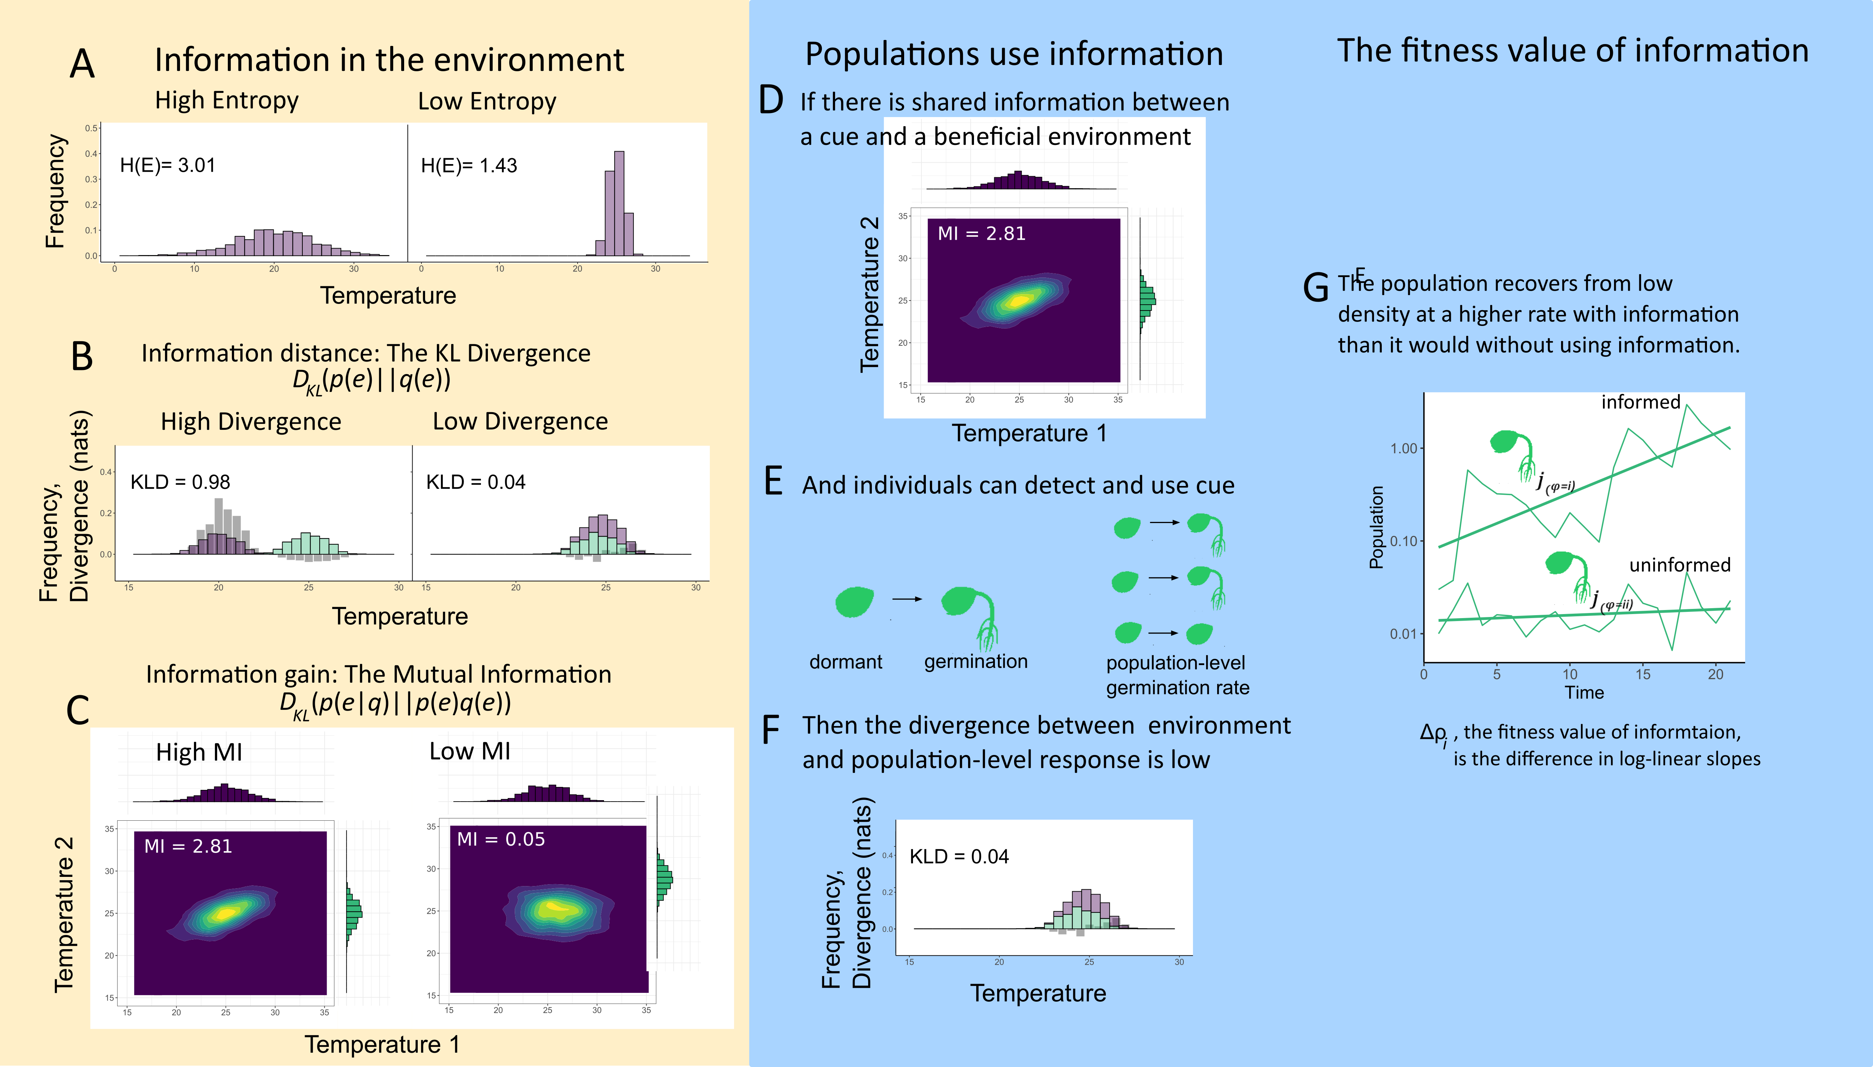
Figure 1 specific comments:
Reviewer 1: I really like box 1 and I think figure 1 is partially a visual representation of box one, which is a great idea. However, I have the impression that one could improve the connections between box1 and figure 1 to improve clarity, especially to people less familiar with entropy and KL-divergence. Optimally, you have for each of the terms in equation B1.4 a graphical representation. Additionally, for some of the other terms occurring in box 1 would help.
--Graphical representation of elements in Box 1/Figure 1. More correspondence of elements? Also suggested by Reviewer 3.
L365: FVOI and MI are not explicitly visible in figure 1, please change accordingly

Reviewer 3: Simplify where possible. The derivations in box 1 are challenging to follow. I’d just refer readers to Cover and Thomas, and use this space to qualitatively describe KL-divergence and mutual information. In addition to derivations, Cover and Thomas have a nice venn diagram of the link between these concepts in the first chapter or two of their textbook (Figure 2.2 in my edition). I think a visual example would help more than the arithmetic.
This could be done better in Figure 1 as a compromise, as per the editor’s comments?

I think figure 1 should be simpflied. It would be easier to picutre the arithmetic if you replaced the continous variable (rain) with a categorical variable (wet/dry). The germinating seeds should be replaced with a simpler icon.

Editor:
Both reviewer 1 and reviewer 3 wanted more pictorial/schematic explanations of Box 1. I think you could take out some of Fig. 1, which I found a little vague in places, and devote some space here to visually explaining some of the concepts in Box 1. For example, instead of simply drawing two distributions in panel D, you could draw two distributions and then have vertical lines showing the element-wise difference between them as a way of motivating the KL divergence. Please do keep the math in Box 1, however! Some readers (like me) very much need the equations if we are to understand.
Fig. 1, panel E: Delta \rho appears to be the difference in size of the final populations, which is not its mathematical definition.
I found fig. 1 to be only modestly helpful. The caption was somewhat helpful but the schematics that went with it, somewhat less so.
Figure 1. Conceptual layout of the fitness value of information (FVOI). In order for populations to benefit, there Estimating FVOI requires (A) time-series observations of two environmental variables, here hypothetical temporal trends of rain in January and total annual rain, where rain in January serves as a cue for total rain during the growing season. The fitness value of this cue is equal to the mutual information (MI) between the two time series (labeled “C” for cue and “E” for environment). Estimating FVOI also requires observations of (B) population dynamics in a variable environment, where per capita growth rates vary according to the favorability of conditions in a generation (a year, for this hypothetical annual plant). (C) A population’s varying response may correspond with underlying differences amongst individuals or phenotypes to detect and/or respond to an available cue: for example, different seed phenotypes that respond physiological to different levels of rain in January (in other examples, the response could be behavioral). (D) A population will capitalize on information (MI, panel A) to the extent that it has an accurate “internal model” of how cues correspond with desired environments. This is measured formally with the Kullback-Leibler divergence (D_{KL}) between the actual probability of seeing an environmental state (here, histogram of the magnitude of total rainfall) and the population’s internal representation of this histogram (here, the frequency of phenotypes corresponds with each environmental state’s likelihood). (E) The FVOI (Δ𝜌) is the difference in log per-capita growth rates between a population that is able to utilize a cue, and one that does not.

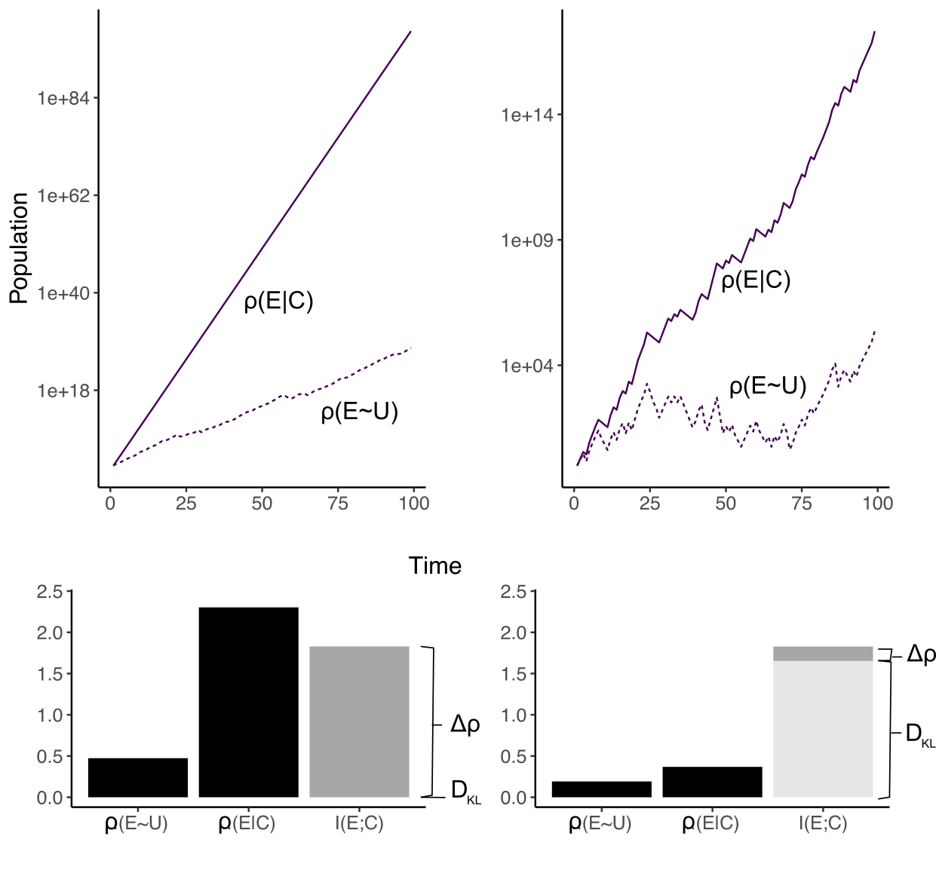
A
B
C
D
Figure 2. Population growth for two life history models: a multiplicative model (A) and a dormancy model (B) when the probability of a strategy or phenotype does not use information 𝜌(E~U), versus when it uses an environmental cue for information 𝜌(E|C) (see text and model details in box 1). To illustrate the relative contributions of I(E;C) and each population to the FVOI, values of the slopes 𝜌(U) and 𝜌(E|C) are shown in C and D for each model. The fitness value of information is measured by the difference between the two slopes Δ𝜌. The mutual information I(E;C) between the environment and the cue defines the maximum potential contribution of a cue to fitness, while the KL Divergence (D_{KL}) quantifies the extent to which a population fails to benefit from an informative cue; the stacked bars in C and D illustrate that the FVOI is the difference between I(E;C) and D_{KL}. See the Supporting Information for simulation details.

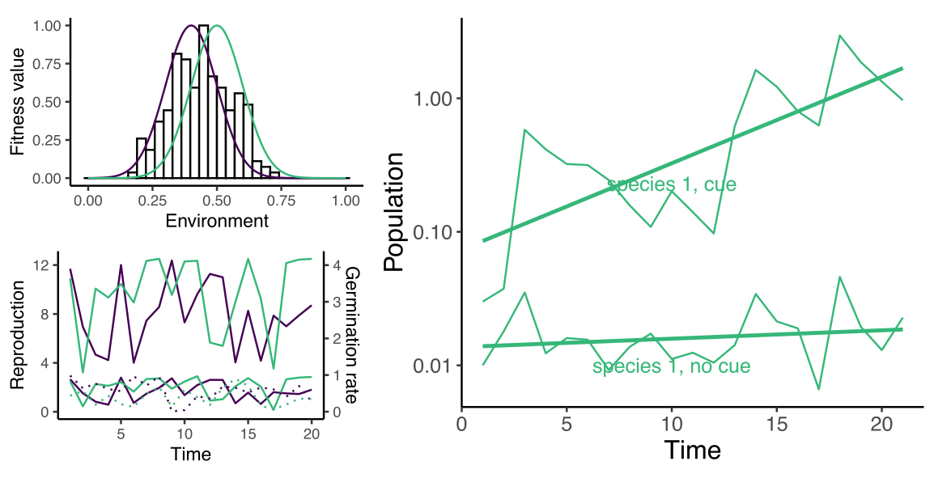
A
B
C
Figure 3. The dynamics of the lottery model (A) for a population with and without the ability to detect an environmental cue in a varying environment. The environment is simulated by taking draws from a normal distribution to set the conditions for each time step, without autocorrelation (μ = 0.5 and σ =0.1, B). Each species has a different optimum environment, shown as the two Gaussian curves (B): fitness decays with the distance of an environmental state from the optimum. (C ) The varying environmental state, fitness, and germination rate are simulated as a time series. Germination is simulated in two ways: when populations use an informative cue ( i.e. 𝜌(E|C) ), the distribution of germination rates is highly correlated with the fitness series (solid lines - compare green solid line trajectories for reproduction rate and germination rate); when species cannot use information, germination is a random uniform distribution that is uncorrelated with fitness ( i.e. 𝜌(U); dotted lines). See the Supporting Information for simulation details.

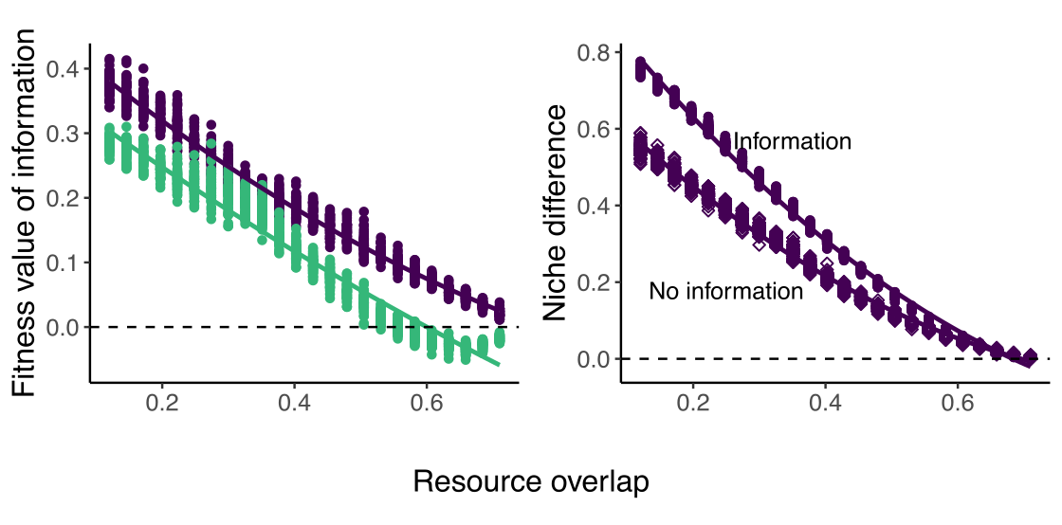
A
B
Figure 4. The change in the fitness value of information for two species (one blue, one purple) competing for fluctuating resources. Competition increases with more resource overlap because species will reproduce more often under similar conditions and limit the growth of the other. (A) The fitness value of information Δ𝜌 decreases when competition for resources increases. (B) The niche difference between species in the presence and absence of information (i.e. 𝜌(E|C) and 𝜌(U) ) as labelled. A niche difference of 1 corresponds with 100% differentiation.

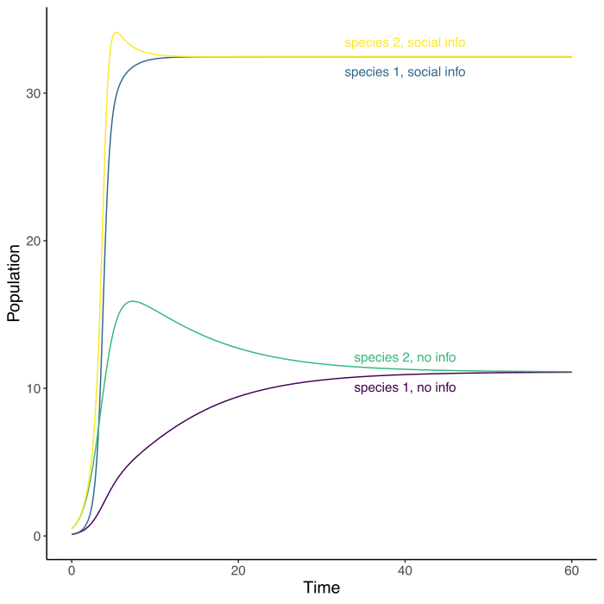
Figure 5. The population dynamics of the competition model with social information, with (upper lines) and without (lower lines) social information.

Bibliography

Acharya, L. & Fenton, M.B. (2011). Bat attacks and moth defensive behaviour around street lights. Can. J. Zool.
Adler, P.B., HilleRisLambers, J., Kyriakidis, P.C., Guan, Q. & Levine, J.M. (2006). Climate variability has a stabilizing effect on the coexistence of prairie grasses. Proc. Natl. Acad. Sci., 103, 12793–12798.
Adler, P.B., HilleRisLambers, J. & Levine, J.M. (2007). A niche for neutrality. Ecol. Lett., 10, 95–104.
Alexander, J.M. & Levine, J.M. (2019). Earlier phenology of a nonnative plant increases impacts on native competitors. Proc. Natl. Acad. Sci., 116, 6199–6204.
Angert, A.L., Huxman, T.E., Chesson, P. & Venable, D.L. (2009). Functional tradeoffs determine species coexistence via the storage effect. Proc. Natl. Acad. Sci., 106, 11641–11645.
Aplin, L.M., Farine, D.R., Morand-Ferron, J., Cockburn, A., Thornton, A. & Sheldon, B.C. (2015). Experimentally induced innovations lead to persistent culture via conformity in wild birds. Nature, 518, 538–541.
Baldwin, I.T., Halitschke, R., Paschold, A., Von Dahl, C.C. & Preston, C.A. (2006). Volatile signaling in plant-plant interactions:" talking trees" in the genomics era. science, 311, 812–815.
Barabás, G., D’Andrea, R. & Stump, S.M. (2018). Chesson’s coexistence theory. Ecol. Monogr., 88, 277–303.
Barber, J.R., Crooks, K.R. & Fristrup, K.M. (2010). The costs of chronic noise exposure for terrestrial organisms. Trends Ecol. Evol., 25, 180–189.
Barbraud, C. & Weimerskirch, H. (2003). Climate and density shape population dynamics of a marine top predator. Proc. R. Soc. Lond. B Biol. Sci., 270, 2111–2116.
Barth, F.G. & Schmid, A. (2013). Ecology of sensing. Springer Science & Business Media.
Barton, B.T., Hodge, M.E., Speights, C.J., Autrey, A.M., Lashley, M.A. & Klink, V.P. (2018). Testing the AC/DC hypothesis: Rock and roll is noise pollution and weakens a trophic cascade. Ecol. Evol., 8, 7649–7656.
Bernhardt, J.R., O’Connor, M.I., Sunday, J.M. & Gonzalez, A. (2020). Life in fluctuating environments. Philos. Trans. R. Soc. B, 375, 20190454.
Berryman, A.A., Dennis, B., Raffa, K.F. & Stenseth, N.C. (1985). Evolution of optimal group attack, with particular reference to bark beetles (Coleoptera: Scolytidae). Ecology, 66, 898–903.
Bever, J.D. & Simms, E.L. (2000). Evolution of nitrogen fixation in spatially structured populations of Rhizobium. Heredity, 85, 366–372.
Boeing, W.J. & Ramcharan, C.W. (2010). Inducible defences are a stabilizing factor for predator and prey populations: a field experiment. Freshw. Biol., 55, 2332–2338.
Bolker, B.M., Pacala, S.W. & Neuhauser, C. (2003). Spatial dynamics in model plant communities: What do we really know? Am. Nat., 162, 135–148.
Bronson, F.H. (2009). Climate change and seasonal reproduction in mammals. Philos. Trans. R. Soc. B Biol. Sci., 364, 3331–3340.
Bruce, T.J., Matthes, M.C., Napier, J.A. & Pickett, J.A. (2007). Stressful “memories” of plants: evidence and possible mechanisms. Plant Sci., 173, 603–608.
Brumm, H., Voss, K., Köllmer, I. & Todt, D. (2004). Acoustic communication in noise: regulation of call characteristics in a New World monkey. J. Exp. Biol., 207, 443–448.
Bullmore, E. & Sporns, O. (2012). The economy of brain network organization. Nat. Rev. Neurosci., 13, 336–349.
Cáceres, C.E. (1997). Temporal variation, dormancy, and coexistence: A field test of the storage effect. Proc. Natl. Acad. Sci. U. S. A., 94, 9171–9175.
Cai, Y., Hossain, M.J., Hériché, J.-K., Politi, A.Z., Walther, N., Koch, B., et al. (2018). Experimental and computational framework for a dynamic protein atlas of human cell division. Nature, 561, 411–415.
Carroll, I.T., Cardinale, B.J. & Nisbet, R.M. (2011). Niche and fitness differences relate the maintenance of diversity to ecosystem function. Ecology, 92, 1157–1165.
Chesson, P. (1994). Multispecies Competition in Variable Environments. Theor. Popul. Biol., 45, 227–276.
Chesson, P.L. & Warner, R.R. (1981). Environmental variability promotes coexistence in lottery competitive systems. Am. Nat., 117, 923.
Childs, D.Z., Metcalf, C.J.E. & Rees, M. (2010). Evolutionary bet-hedging in the real world: empirical evidence and challenges revealed by plants. Proc. R. Soc. B Biol. Sci., 277, 3055–3064.
Chivers, D.P. & Smith, R.J.F. (1998). Chemical alarm signalling in aquatic predator-prey systems: a review and prospectus. Ecoscience, 5, 338–352.
Clauss, M.J. & Venable, D.L. (2000). Seed Germination in Desert Annuals: An Empirical Test of Adaptive Bet Hedging. Am. Nat., 155, 168–186.
Cohen, D. (1966). Optimizing reproduction in a randomly varying environment. J. Theor. Biol., 12, 119–129.
Commander, L.E., Golos, P.J., Miller, B.P. & Merritt, D.J. (2017). Seed germination traits of desert perennials. Plant Ecol., 218, 1077–1091.
Costerton, J.W., Lewandowski, Z., Caldwell, D.E., Korber, D.R. & Lappin-Scott, H.M. (1995). Microbial biofilms. Annu. Rev. Microbiol., 49, 711–745.
Cotton, P.A. (2003). Avian migration phenology and global climate change. Proc. Natl. Acad. Sci., 100, 12219–12222.
Cover, T.M. & Thomas, J.A. (2006). Elements of Information Theory. John Wiley & Sons.
Crespi, B.J. (2001). The evolution of social behavior in microorganisms. Trends Ecol. Evol., 16, 178–183.
Crisp, P.A., Ganguly, D., Eichten, S.R., Borevitz, J.O. & Pogson, B.J. (2016). Reconsidering plant memory: Intersections between stress recovery, RNA turnover, and epigenetics. Sci. Adv., 2, e1501340.
Crone, E.E., Miller, E. & Sala, A. (2009). How do plants know when other plants are flowering? Resource depletion, pollen limitation and mast-seeding in a perennial wildflower. Ecol. Lett., 12, 1119–1126.
Danchin, E., Giraldeau, L.-A., Valone, T.J. & Wagner, R.H. (2004). Public information: from nosy neighbors to cultural evolution. Science, 305, 487–491.
Dangles, O., Irschick, <? break?> Duncan, Chittka, <? break?> Lars & Casas, <? break?> Jérôme. (2009). Variability in sensory ecology: expanding the bridge between physiology and evolutionary biology. Q. Rev. Biol., 84, 51–74.
De Moraes, C.M., Lewis, W.J., Paré, P.W., Alborn, H.T. & Tumlinson, J.H. (1998). Herbivore-infested plants selectively attract parasitoids. Nature, 393, 570–573.
Devaux, C. & Lande, R. (2009). Displacement of flowering phenologies among plant species by competition for generalist pollinators. J. Evol. Biol., 22, 1460–1470.
Donaldson-Matasci, M.C., Bergstrom, C.T. & Lachmann, M. (2010). The fitness value of information. Oikos, 119, 219–230.
Donaldson-Matasci, M.C., Lachmann, M. & Bergstrom, C.T. (2008). Phenotypic diversity as an adaptation to environmental uncertainty. Evol. Ecol. Res., 10, 493–515.
Durrett, R. & Levin, S. (1997). Allelopathy in spatially distributed populations. J. Theor. Biol., 185, 165–171.
Ellner, S. (1987). Alternate plant life history strategies and coexistence in randomly varying environments. Vegetatio, 69, 199–208.
Ellner, S.P. (1997). You bet your life: life-history strategies in fluctuating environments. Case Stud. Math. Model. Ecol. Physiol. Cell Biol., 3–24.
Ellner, S.P., Snyder, R.E. & Adler, P.B. (2016). How to quantify the temporal storage effect using simulations instead of math. Ecol. Lett.
Fabina, N.S., Abbott, K.C. & Gilman, R.T. (2010). Sensitivity of plant–pollinator–herbivore communities to changes in phenology. Ecol. Model., 221, 453–458.
Firebaugh, A. & Haynes, K.J. (2019). Light pollution may create demographic traps for nocturnal insects. Basic Appl. Ecol., 34, 118–125.
Frank, S.A. (2012). Natural selection. V. How to read the fundamental equations of evolutionary change in terms of information theory. J. Evol. Biol., 25, 2377–2396.
Frank, S.A. (2016). The invariances of power law size distributions. F1000Research, 5.
Furness, A.I., Lee, K. & Reznick, D.N. (2015). Adaptation in a variable environment: Phenotypic plasticity and bet-hedging during egg diapause and hatching in an annual killifish. Evolution, 69, 1461–1475.
Gil, M.A., Baskett, M.L. & Schreiber, S.J. (2019). Social information drives ecological outcomes among competing species. Ecology, 100, e02835.
Gil, M.A., Emberts, Z., Jones, H. & St. Mary, C.M. (2017). Social information on fear and food drives animal grouping and fitness. The American Naturalist, 189, 227–241.
Gil, M.A., Hein, A.M., Spiegel, O., Baskett, M.L. & Sih, A. (2018). Social information links individual behavior to population and community dynamics. Trends Ecol. Evol., 33, 535–548.
Gillespie, J.H. (1974). Natural selection for within-generation variance in offspring number. Genetics, 76, 601–606.
Godoy, O. & Levine, J.M. (2014). Phenology effects on invasion success: insights from coupling field experiments to coexistence theory. Ecology, 95, 726–736.
Goldenfeld, N. & Woese, C. (2007). Biology’s next revolution. Q-Bio0702015.
Gould, J.P. (1974). Risk, stochastic preference, and the value of information. J. Econ. Theory, 8, 64–84.
Grainger, T.N., Levine, J.M. & Gilbert, B. (2019). The Invasion Criterion: A Common Currency for Ecological Research. Trends Ecol. Evol., 34, 925–935.
Hairston Jr, N.G. & Kearns, C.M. (1995). The interaction of photoperiod and temperature in diapause timing: a copepod example. Biol. Bull., 189, 42–48.
Hairston, N.G. & Dillon, T.A. (1990). Fluctuating selection and response in a population of freshwater copepods. Evolution, 44, 1796–1805.
Haldane, J.B.S. & Jayakar, S.D. (1963). Polymorphism due to selection of varying direction. J. Genet., 58, 237–242.
Hammill, E., Rogers, A. & Beckerman, A.P. (2008). Costs, benefits and the evolution of inducible defences: a case study with Daphnia pulex. J. Evol. Biol., 21, 705–715.
Hart, S.P., Usinowicz, J. & Levine, J.M. (2017). The spatial scales of species coexistence. Nat. Ecol. Evol., 1, 1066.
Harvell, C.D. (1992). Inducible defenses and allocation shifts in a marine bryozoan. Ecology, 73, 1567–1576.
Hegland, S.J., Nielsen, A., Lázaro, A., Bjerknes, A.-L. & Totland, Ø. (2009). How does climate warming affect plant-pollinator interactions? Ecol. Lett., 12, 184–195.
Hein, A.M. & Martin, B.T. (2020). Information limitation and the dynamics of coupled ecological systems. Nature Ecology & Evolution, 4, 82–90.
Horton, K.G., La Sorte, F.A., Sheldon, D., Lin, T.-Y., Winner, K., Bernstein, G., et al. (2020). Phenology of nocturnal avian migration has shifted at the continental scale. Nat. Clim. Change, 10, 63–68.
Horváth, G., Kriska, G., Malik, P. & Robertson, B. (2009). Polarized light pollution: a new kind of ecological photopollution. Front. Ecol. Environ., 7, 317–325.
Huffaker, C. (1958). Experimental studies on predation: dispersion factors and predator-prey oscillations. Hilgardia, 27, 343–383.
Inouye, D.W., Barr, B., Armitage, K.B. & Inouye, B.D. (2000). Climate change is affecting altitudinal migrants and hibernating species. Proc. Natl. Acad. Sci., 97, 1630–1633.
Jackson, S.T., Betancourt, J.L., Booth, R.K. & Gray, S.T. (2009). Ecology and the ratchet of events: climate variability, niche dimensions, and species distributions. Proc. Natl. Acad. Sci., pnas-0901644106.
Jenni, L. & Kéry, M. (2003). Timing of autumn bird migration under climate change: advances in long–distance migrants, delays in short–distance migrants. Proc. R. Soc. Lond. B Biol. Sci., 270, 1467–1471.
Jones, S.E. & Lennon, J.T. (2010). Dormancy contributes to the maintenance of microbial diversity. Proc. Natl. Acad. Sci.
Jose M. Facelli, Peter Chesson & Nicola Barnes. (2008). DIFFERENCES IN SEED BIOLOGY OF ANNUAL PLANTS IN ARID LANDS: A KEY INGREDIENT OF THE STORAGE EFFECT. Available at: http://www.esajournals.org/doi/abs/10.1890/05-0304. Last accessed 8 July 2009.
Kane, A. & Kendall, C.J. (2017). Understanding how mammalian scavengers use information from avian scavengers: cue from above. J. Anim. Ecol., 86, 837–846.
Keller, L. & Surette, M.G. (2006). Communication in bacteria: an ecological and evolutionary perspective. Nat. Rev. Microbiol., 4, 249–258.
Kelly, J.L. (1956). A new interpretation of information rate. Bell Syst. Tech. J., 35, 917–926.
Kempes, C.P., Wolpert, D., Cohen, Z. & Pérez-Mercader, J. (2017). The thermodynamic efficiency of computations made in cells across the range of life. Phil Trans R Soc A, 375, 20160343.
Koch, K. (2004). Sucrose metabolism: regulatory mechanisms and pivotal roles in sugar sensing and plant development. Curr. Opin. Plant Biol., 7, 235–246.
Koštál, V., Štětina, T., Poupardin, R., Korbelová, J. & Bruce, A.W. (2017). Conceptual framework of the eco-physiological phases of insect diapause development justified by transcriptomic profiling. Proc. Natl. Acad. Sci., 114, 8532–8537.
Kussell, E. & Leibler, S. (2005). Phenotypic diversity, population growth, and information in fluctuating environments. Science, 309, 2075–2078.
Laughlin, S.B., van Steveninck, R.R. de R. & Anderson, J.C. (1998). The metabolic cost of neural information. Nat. Neurosci., 1, 36–41.
Leff, H.S. & Rex, A.F. (2014). Maxwell’s demon: entropy, information, computing. Princeton University Press.
Letten, A.D., Dhami, M.K., Ke, P.-J. & Fukami, T. (2018). Species coexistence through simultaneous fluctuation-dependent mechanisms. Proc. Natl. Acad. Sci., 201801846.
Levin, S.A. (1992). The problem of pattern and scale in ecology: the Robert H. MacArthur award lecture. Ecology, 73, 1943–1967.
Longcore, T. & Rich, C. (2004). Ecological light pollution. Front. Ecol. Environ., 2, 191–198.
Magrath, R.D., Haff, T.M., Fallow, P.M. & Radford, A.N. (2015). Eavesdropping on heterospecific alarm calls: from mechanisms to consequences. Biol. Rev., 90, 560–586.
Marleau, J.N., Peller, T., Guichard, F. & Gonzalez, A. (2020). Converting Ecological Currencies: Energy, Material, and Information Flows. Trends Ecol. Evol.
McMahon, T.A., Rohr, J.R. & Bernal, X.E. (2017). Light and noise pollution interact to disrupt interspecific interactions. Ecology, 98, 1290–1299.
McNamara, J.M., Barta, Z., Klaassen, M. & Bauer, S. (2011). Cues and the optimal timing of activities under environmental changes. Ecol. Lett., 14, 1183–1190.
Miehls, A.L., McAdam, A.G., Bourdeau, P.E. & Peacor, S.D. (2013). Plastic response to a proxy cue of predation risk when direct cues are unreliable. Ecology, 94, 2237–2248.
Moeller, D.A. (2004). Facilitative interactions among plants via shared pollinators. Ecology, 85, 3289–3301.
Montgomery, R.A., Rice, K.E., Stefanski, A., Rich, R.L. & Reich, P.B. (2020). Phenological responses of temperate and boreal trees to warming depend on ambient spring temperatures, leaf habit, and geographic range. Proc. Natl. Acad. Sci., 117, 10397–10405.
Nelson, M.E. & MacIver, M.A. (2006). Sensory acquisition in active sensing systems. J. Comp. Physiol. A, 192, 573–586.
O’Connor, M.I., Pennell, M.W., Altermatt, F., Matthews, B., Melián, C.J. & Gonzalez, A. (2019). Principles of Ecology Revisited: Integrating Information and Ecological Theories for a More Unified Science. Front. Ecol. Evol., 7.
Pake, C.E. & Venable, D.L. (1995). Is Coexistence of Sonoran Desert Annuals Mediated by Temporal Variability Reproductive Success. Ecology, 76, 246–261.
Parrondo, J.M., Horowitz, J.M. & Sagawa, T. (2015). Thermodynamics of information. Nat. Phys., 11, 131–139.
Patricelli, G.L. & Blickley, J.L. (2006). Avian communication in urban noise: causes and consequences of vocal adjustment. The Auk, 123, 639–649.
Peacor, S.D. & Werner, E.E. (2004). How dependent are species-pair interaction strengths on other species in the food web? Ecology, 85, 2754–2763.
Pennekamp, F., Iles, A.C., Garland, J., Brennan, G., Brose, U., Gaedke, U., et al. (2019). The intrinsic predictability of ecological time series and its potential to guide forecasting. Ecol. Monogr., 89, e01359.
Philippi, T. & Seger, J. (1989). Hedging one’s evolutionary bets, revisited. Trends Ecol. Evol., 4, 41–44.
Post, E. & Forchhammer, M.C. (2008). Climate change reduces reproductive success of an Arctic herbivore through trophic mismatch. Philos. Trans. R. Soc. B Biol. Sci., 363, 2367–2373.
Relyea, R.A. (2003). Predators come and predators go: the reversibility of predator-induced traits. Ecology, 84, 1840–1848.
Rivoire, O. & Leibler, S. (2011). The value of information for populations in varying environments. J. Stat. Phys., 142, 1124–1166.
Robertson, B.A., Rehage, J.S. & Sih, A. (2013). Ecological novelty and the emergence of evolutionary traps. Trends Ecol. Evol., 28, 552–560.
Salmon, M., Tolbert, M.G., Painter, D.P., Goff, M. & Reiners, R. (1995). Behavior of Loggerhead Sea Turtles on an Urban Beach. II. Hatchling Orientation. J. Herpetol., 29, 568–576.
Schauber, E.M., Kelly, D., Turchin, P., Simon, C., Lee, W.G., Allen, R.B., et al. (2002). Masting by Eighteen New Zealand Plant Species: The Role of Temperature as a Synchronizing Cue. Ecology, 83, 1214–1225.
Schlaepfer, M.A., Runge, M.C. & Sherman, P.W. (2002). Ecological and evolutionary traps. Trends Ecol. Evol., 17, 474–480.
Schmidt, K.A., Johansson, J. & Betts, M.G. (2015). Information-mediated Allee effects in breeding habitat selection. Am. Nat., 186, E162–E171.
Sears, A.L. & Chesson, P. (2007). New methods for quantifying the spatial storage effect: an illustration with desert annuals. Ecology, 88, 2240–2247.
Secor, D.H. (2007). The year-class phenomenon and the storage effect in marine fishes. J. Sea Res., 57, 91–103.
Shoemaker, L.G. & Melbourne, B.A. (2016). Linking metacommunity paradigms to spatial coexistence mechanisms. Ecology, 97, 2436–2446.
Smith, J.M. (1999). The idea of information in biology. Q. Rev. Biol., 74, 395–400.
Snyder, R.E. (2006). Multiple risk reduction mechanisms: can dormancy substitute for dispersal? Ecol. Lett., 9, 1106–1114.
Stephens, D.W. (1989). Variance and the value of information. Am. Nat., 134, 128–140.
Stephens, P.A., Frey-roos, F., Arnold, W. & Sutherland, W.J. (2002). Model complexity and population predictions. The alpine marmot as a case study. J. Anim. Ecol., 71, 343–361.
Strauss, S.Y. (1997). Floral Characters Link Herbivores, Pollinators, and Plant Fitness. Ecology, 78, 1640–1645.
Stumpf, M.P., Laidlaw, Z. & Jansen, V.A. (2002). Herpes viruses hedge their bets. Proc. Natl. Acad. Sci., 99, 15234–15237.
Sultan, S.E. (2000). Phenotypic plasticity for plant development, function and life history. Trends Plant Sci., 5, 537–542.
Suttle, K.B., Thomsen, M.A. & Power, M.E. (2007). Species interactions reverse grassland responses to changing climate. science, 315, 640–642.
Ten Brink, H., Gremer, J.R. & Kokko, H. (2020). Optimal germination timing in unpredictable environments: the importance of dormancy for both among-and within-season variation. Ecol. Lett., 23, 620–630.
Thackeray, S.J., Henrys, P.A., Hemming, D., Bell, J.R., Botham, M.S., Burthe, S., et al. (2016). Phenological sensitivity to climate across taxa and trophic levels. Nature, 535, 241–245.
Tielbörger, K., Petru\uu, M. & Lampei, C. (2012). Bet-hedging germination in annual plants: a sound empirical test of the theoretical foundations. Oikos, 121, 1860–1868.
Tkačik, G. & Bialek, W. (2016). Information processing in living systems. Annu. Rev. Condens. Matter Phys., 7, 89–117.
Turelli, M. (1978). Does environmental variability limit niche overlap? Proc. Natl. Acad. Sci., 75, 5085–5089.
Tyson, J.J., Csikasz-Nagy, A. & Novak, B. (2002). The dynamics of cell cycle regulation. Bioessays, 24, 1095–1109.
Tyson, R. & Lutscher, F. (2016). Seasonally varying predation behavior and climate shifts are predicted to affect predator-prey cycles. Am. Nat., 188, 539–553.
Usinowicz, J. (2015). Limited Dispersal Drives Clustering and Reduces Coexistence by the Storage Effect. Am. Nat., 186, 634–648.
Usinowicz, J., Chang-Yang, C.-H., Chen, Y.-Y., Clark, J.S., Fletcher, C., Garwood, N.C., et al. (2017). Temporal coexistence mechanisms contribute to the latitudinal gradient in forest diversity. Nature, 550, 105–108.
Usinowicz, J., Wright, S.J. & Ives, A.R. (2012). Coexistence in tropical forests through asynchronous variation in annual seed production. Ecology, 93, 2073–2084.
Venable, D.L. & Lawlor, L. (1980). Delayed germination and dispersal in desert annuals: escape in space and time. Oecologia, 46, 272–282.
Werner, E.E. & Peacor, S.D. (2003). A review of trait-mediated indirect interactions in ecological communities. Ecology, 84, 1083–1100.
Williams, P., Camara, M., Hardman, A., Swift, S., Milton, D., Hope, V.J., et al. (2000). Quorum sensing and the population-dependent control of virulence. Philos. Trans. R. Soc. Lond. B. Biol. Sci., 355, 667–680.
Wilsterman, K., Ballinger, M.A. & Williams, C.M. (2021). A unifying, eco-physiological framework for animal dormancy. Funct. Ecol., 35, 11–31.
Woods, H.A. & Wilson, J.K. (2013). An information hypothesis for the evolution of homeostasis. Trends Ecol. Evol., 28, 283–289.

